Privacy Policy Inference of User Uploaded Images on Content Sharing Sites

Abstract:

With the increasing volume of images users share through social sites, maintaining privacy has become a major problem, as demonstrated by a recent wave of publicized incidents where users inadvertently shared personal information. In light of these incidents, the need of tools to help users control access to their shared content is apparent. Toward addressing this need, we propose an Adaptive Privacy Policy Prediction (A3P) system to help users compose privacy settings for their images. We examine the role of social context, image content, and metadata as possible indicators of users’ privacy preferences. We propose a two-level framework which according to the user’s available history on the site, determines the best available privacy policy for the user’s images being uploaded. Our solution relies on an image classification framework for image categories which may be associated with similar policies, and on a policy prediction algorithm to automatically generate a policy for each newly uploaded image, also according to users’ social features. Over time, the generated policies will follow the evolution of users’ privacy attitude. We provide the results of our extensive evaluation over 5,000 policies, which demonstrate the effectiveness of our system, with prediction accuracies over 90 percent.

Existing System:

Most content sharing websites allow users to enter their privacy preferences. Unfortunately, recent studies have shown that users struggle to set up and maintain such privacy settings . One of the main reasons provided is that given the amount of shared information this process can be tedious and error-prone. Therefore, many have acknowledged the need of policy recommendation systems which can assist users to easily and properly configure privacy settings . However, existing proposals for automating privacy settings appear to be inadequate to address the unique privacy needs of images , due to the amount of information implicitly carried within images, and their relationship with the online environment wherein they are exposed.

Proposed System:

In proposed System an Adaptive Privacy Policy Prediction (A3P) system that helps users automate the privacy policy settings for their uploaded images. The A3P system provides a comprehensive framework to infer privacy preferences based on the information available for a given user. We also effectively tackled the issue of cold-start, leveraging social context information. Our experimental study proves that our A3P is a practical tool that offers significant improvements over current approaches to privacy.

Advantages:

Maintain both efficiency and high prediction accuracy of a system.

Scope: User uploads an image, it is handled as an input query image. The signature of the newly uploaded image is compared with the signatures of images in the current image database. To determine the class of the uploaded image, we find its first m closest matches. The class of the uploaded image is then calculated as the class to which majority of the m images belong. If no predominant class is found, a new class is created for the image. Later on, if the predicted policy for this new image turns out correct, the image will be inserted into the corresponding image category in our image database, to help refine future policy prediction. In our current prototype, m is set to 25 which is obtained using a small training data set.

Problem Statement: consider social context such as one’s friend list. While interesting, they may not be sufficient to address challenges brought by image files for which privacy may vary substantially not just because of social context but also due to the actual image content. As far as images, authors in have presented an expressive language for images uploaded in social sites. This work is complementary to ours as we do not deal with policy expressiveness, but rely on common forms policy specification for our predictive algorithm. In addition, there is a large body of work on image content analysis, for classification and interpretation,retrieval , and photo ranking, also in the context of online photo sharing sites. Of these works, probably the closest to ours. explores privacy-aware image classification using a mixed set of features, both content and meta-data. This is however a binary classification (private versus public), so the classification task is very different than ours. Also, the authors do not deal with the issue of cold-start problem.

System Architecture:

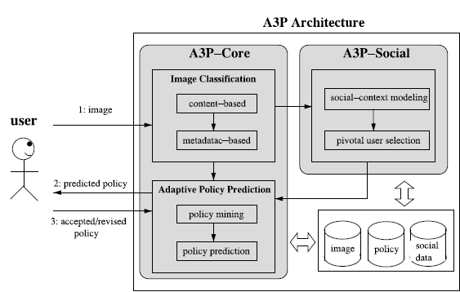

Implementation Modules:

- A3P-CORE

- A3P-SOCIAL

A3P-CORE : There are two major components in A3P-core: (i) Image classification and (ii) Adaptive policy prediction. For each user, his/her images are first classified based on content and metadata. Then, privacy policies of each category of images are analyzed for the policy prediction. Adopting a two-stage approach is more suitable for policy recommendation than applying the common one-stage data mining approaches to mine both image features and policies together
Image classification: Groups of images that may be associated with similar privacy preferences, we propose a hierarchical image classification which classifies images first based on their contents and then refine each category into subcategories based on their metadata. Images that do not have metadata will be grouped only by content. Such a hierarchical classification gives a higher priority to image content and minimizes the influence of missing tags. Note that it is possible that some images are included in multiple categories as long as they contain the typical content features or metadata of those categories.

Adaptive policy prediction: The policy prediction algorithm provides a predicted policy of a newly uploaded image to the user for his/her reference. More importantly, the predicted policy will reflect the possible changes of a user’s privacy concerns. The prediction process consists of three main phases: (i) policy normalization; (ii) policy mining; and (iii) policy prediction.

(1)policy normalization: The policy normalization is a simple decomposition process to convert a user policy into a set of atomic rules in which the data (D) component is a single-element set.
(2) policy mining: hierarchical mining first look for popular subjects defined by the user, then look for popular actions in the policies containing the popular subjects, and finally for popular conditions in the policies containing both popular subjects and conditions.
(3) policy prediction: The policy mining phase may generate several candidate policies while the goal of our system is to return the most promising one to the user. Thus, we present an approach to choose the best candidate policy that follows the user’s privacy tendency. To model the user’s privacy tendency, we define a notion of strictness level. The strictness level is a quantitative metric that describes how “strict” a policy is.

A3P-SOCIAL:
The A3P-social employs a multi-criteria inference mechanism that generates representative policies by leveraging key information related to the user’s social context and his general attitude toward privacy. As mentioned earlier, A3Psocial will be invoked by the A3P-core in two scenarios. One is when the user is a newbie of a site, and does not have enough images stored for the A3P-core to infer meaningful and customized policies.

Social Context Modeling: The social context modeling algorithm consists of two major steps. The first step is to identify and formalize potentially important factors that may be informative of one’s privacy settings. The second step is to group users based on the identified factors.

Conclusion: We have proposed an Adaptive Privacy Policy Prediction (A3P) system that helps users automate the privacy policy settings for their uploaded images. The A3P system provides a comprehensive framework to infer privacy preferences based on the information available for a given user. We also effectively tackled the issue of cold-start, leveraging social context information. Our experimental study proves that our A3P is a practical tool that offers significant improvements over current approaches to privacy

